Check ohms between these two pins set .2 to .5 ohms
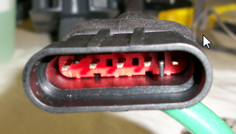
Loosen set screw with 2MM allen wrench (remove Cover cap first)
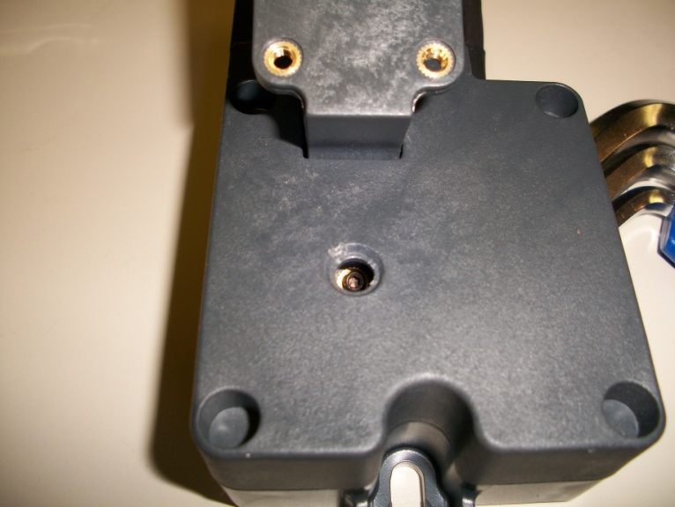
With set screw loose, ohm meter connected to pins shown above, rotate shaft to set ohms, clockwise less - counterclockwise more.
